**Jupyter Notebook and Anaconda Navigator**

**Jupyter Notebook**

As of late 2019, there are two major environments that you can use to run Jupyter Notebooks: Jupyter Notebook (not to be confused with the Jupyter notebook files themselves, which have an .ipynb extension), and the newer Jupyter Lab. Jupyter Notebook is widely-used and well-documented, and provides a simple file browser along with the environment for creating, editing, and running the notebooks. Jupyter Lab is more complex, with a user environment more reminiscent of an Integrated Development Environment (discussed in previous Programming Historian tutorials for Windows, Mac, and Linux). While Jupyter Lab is meant to eventually replace Jupyter Notebook, there is no indication that Jupyter Notebook will stop being supported anytime soon. Because of its comparative simplicity and ease of use for beginners, this tutorial uses Jupyter Notebook as the software for running notebook files. Both software packages are included in Anaconda, described below. It’s easiest to use Anaconda to install Jupyter Notebook, but if you already have Python installed on your system and don’t want to deal with the large Anaconda package, you can run pip3 install jupyter (for Python 3).

**Anaconda**

Anaconda is a free, open-source distribution of Python and R that comes with more than 1,400 packages, the Conda package manager for installing additional packages, and Anaconda Navigator, which allows you to manage environments (e.g. you can install different sets of packages for different projects, so that they don’t cause conflicts for one another) using a graphical interface. After installing Anaconda, you can use Anaconda Navigator to install new packages (or conda install via the command line), but many packages are available only through pip (i.e. using pip install via the command line or in your Jupyter notebook).

For most purposes, you want to download the Python 3 version of Anaconda, but some legacy code may still be written in Python 2. In this lesson, you will be using Python 3. The Anaconda installer is over 500 MB, and after installation it can take upwards of 3 GB of hard drive space, so be sure you have enough room on your computer and a fast network connection before you get started.

To download and install Anaconda, go to the Anaconda website. Make sure you’ve clicked on the icon your operating system (which should change the text Anaconda [version number] for [selected operating system] installer to indicate your operating system), and then click the Download button in the box for the current version of Python 3. If you’re on Windows, this should download an .exe file; on Mac, it’s .pkg; on Linux it’s .sh.

Open the file to install the software as you would normally on your operating system. Further installation details are available in the Anaconda docs, including how to install Anaconda via the command line on each operating system. If your computer is unable to open the file you’ve downloaded, make sure you selected the correct operating system before downloading the installer. On Windows, be sure to choose the option for “Add Anaconda to PATH Variable” during the installation process, or you won’t be able to launch Jupyter notebooks from the command line.

**Installing Anaconda and launching Jupyter Notebook**

**Step 1:** Download Anaconda Installer from “https://www.anaconda.com/products/individual#windows”



**Step 2:** Open the installer and click on Next -> I agree -> Install

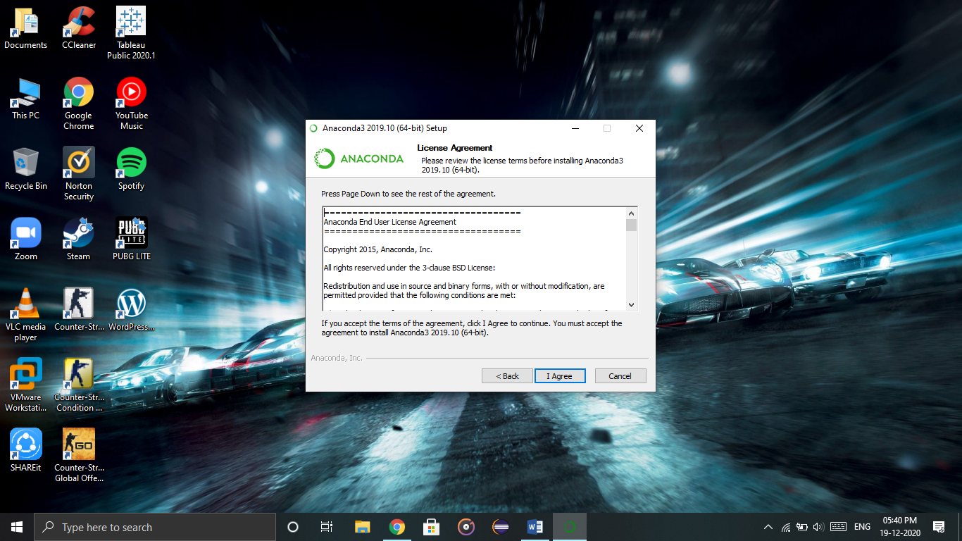

**Step 3:** After completion of installation, open the Anaconda Navigator application. And click on “Launch” button of Jupyter notebook.

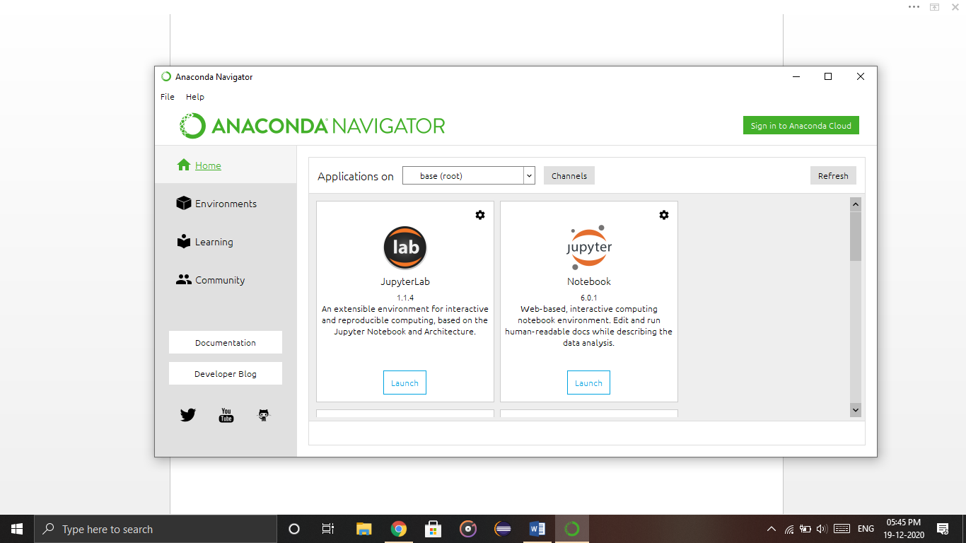

**Step 4:** After clicking this, Jupyter Notebook localhost will be launched on your default browser. It will show your directory. Click on new from top left corner and click Python 3 to open a python (.py) file

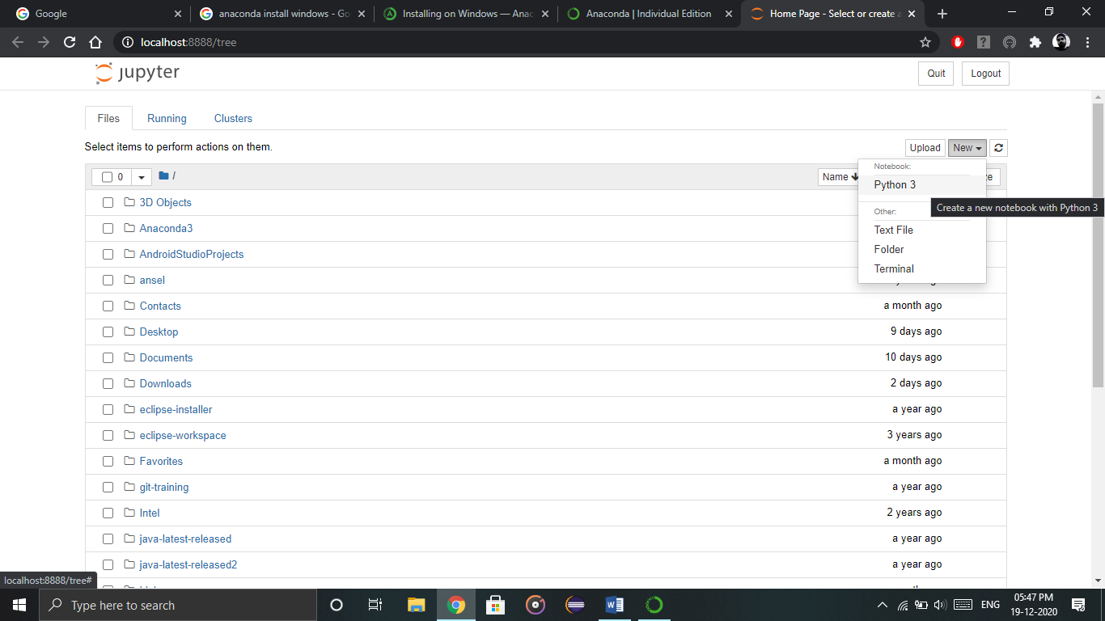

**Step 5:** Once a python file is opened start writing your code. Press “Shift + Enter” to execute/run the code. The file is auto-saved at checkpoints and can be found in the directory where it was created. Rename your file by clicking on “Untitled”.

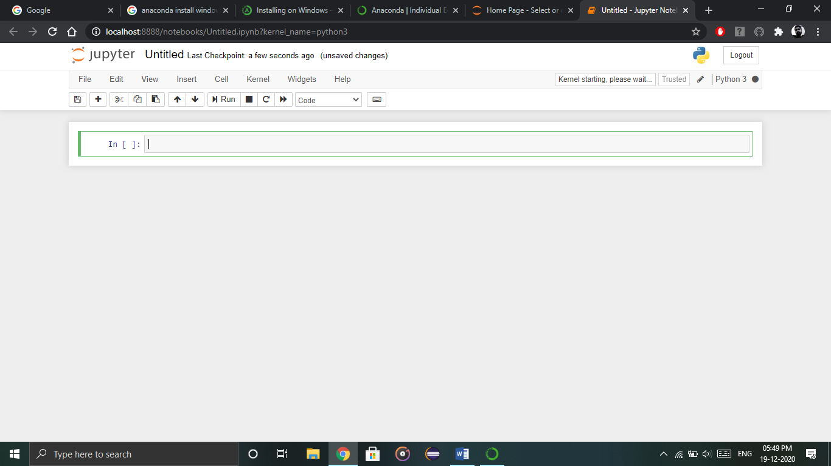

**Installing Anaconda using command prompt**

**Step 1:** Download and Install Anaconda. Go to the Anaconda Website



**Step 2:** Install the downloaded application and click on Finish.

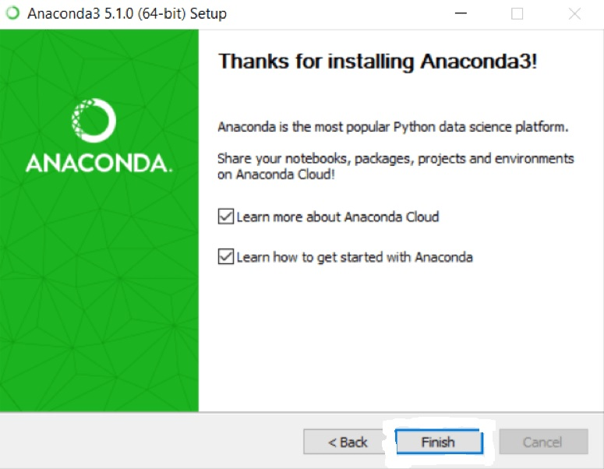

**Step 3:** Go through following

**1.** Open a Command Prompt.

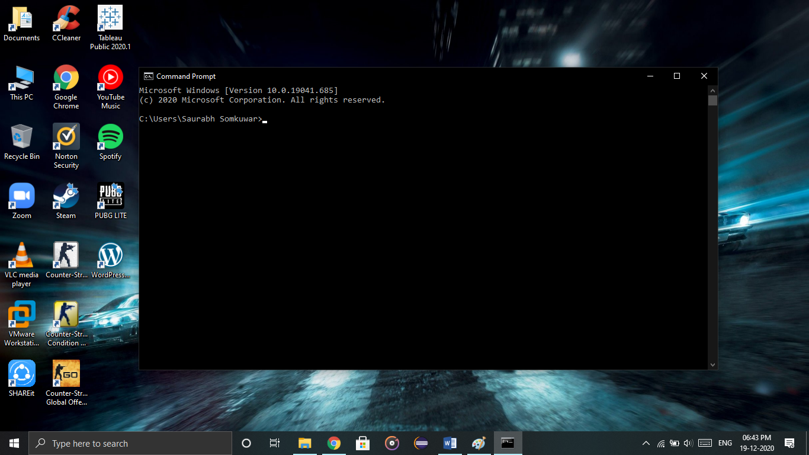

**2.** Check if you already have Anaconda added to your path. Enter the commands below into your Command Prompt. This is checking if you already have Anaconda added to your path.

conda --version

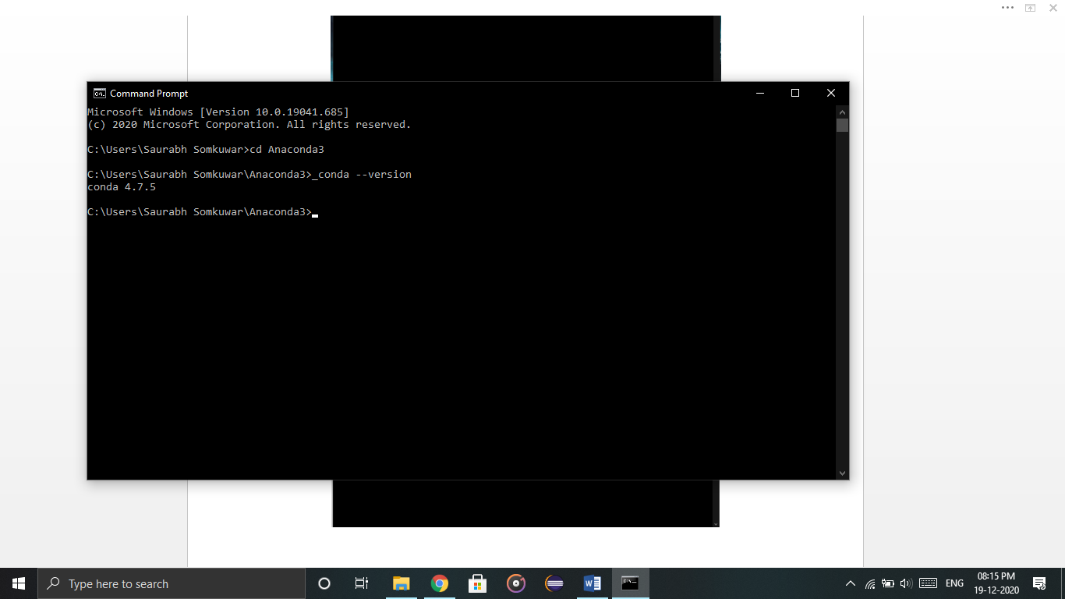

python --version

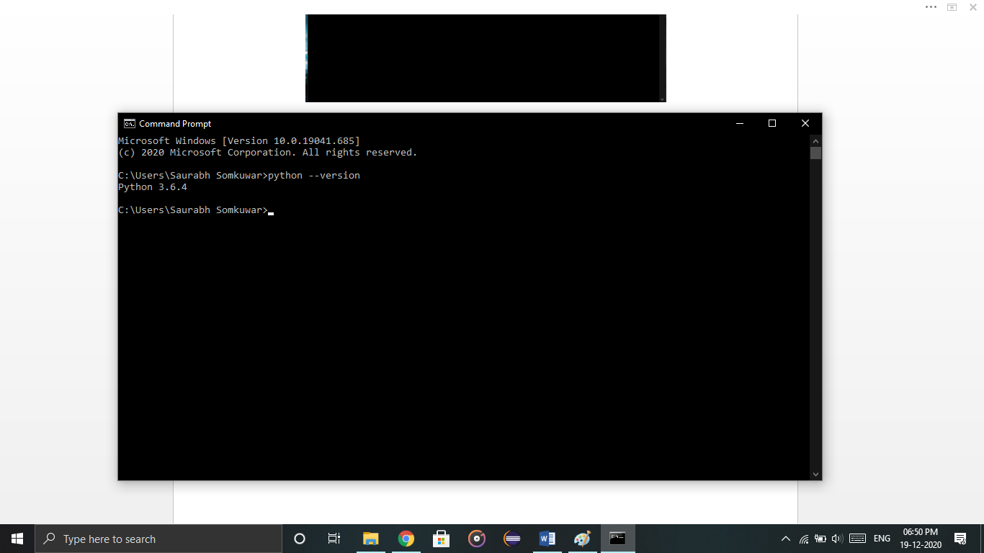

**Installing on Windows**

1. Download the installer:
   * [Miniconda installer for Windows](https://conda.io/miniconda.html).
   * [Anaconda installer for Windows](https://www.anaconda.com/download/).
2. [Verify your installer hashes](https://docs.conda.io/projects/conda/en/latest/user-guide/install/download.html#hash-verification).
3. Double-click the .exe file.
4. Follow the instructions on the screen.

If you are unsure about any setting, accept the defaults. You can change them later.

When installation is finished, from the **Start** menu, open the Anaconda Prompt.

1. Test your installation. In your terminal window or Anaconda Prompt, run the command conda list. A list of installed packages appears if it has been installed correctly.

**Updating conda**

1. Open your Anaconda Prompt from the start menu.
2. Navigate to the anaconda directory.
3. Run conda update conda.

**Installing pip in the windows system**

**Step 1:** Go to ”[www.pip.pypa.io/en/stable/installing](http://www.pip.pypa.io/en/stable/installing)“. Click on get-pip.py and save it to desktop.

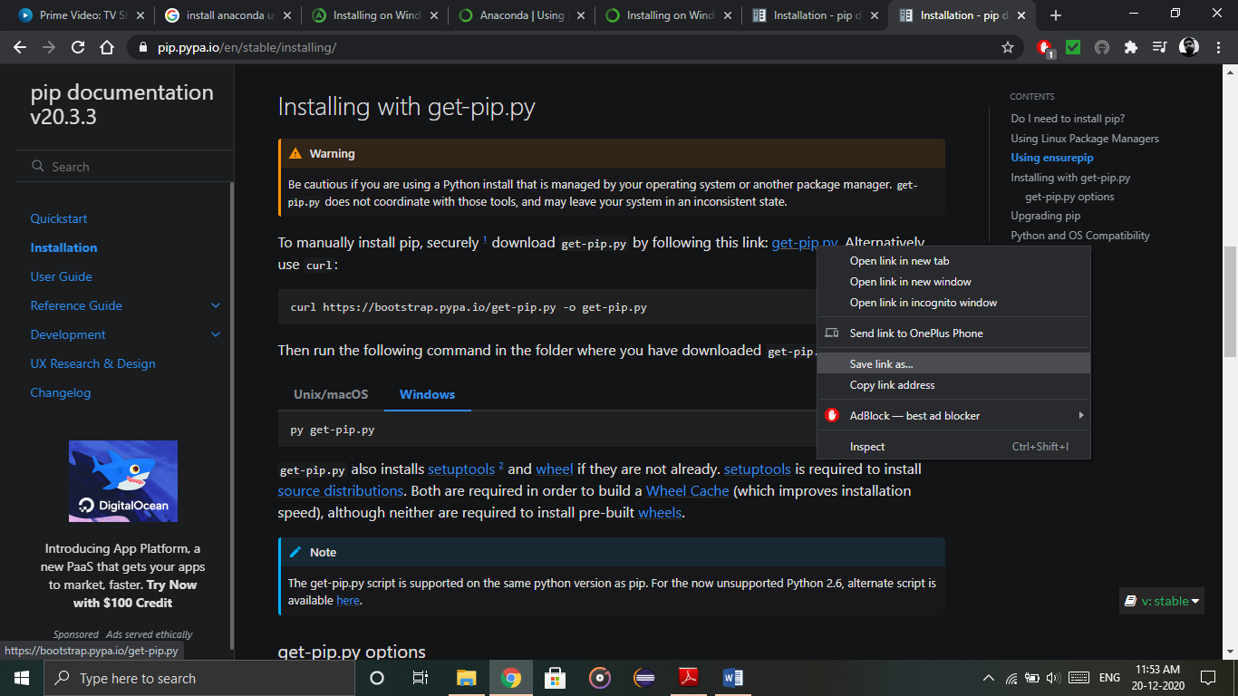

**Step 2:** Open command prompt. Change directory to desktop and install pip.

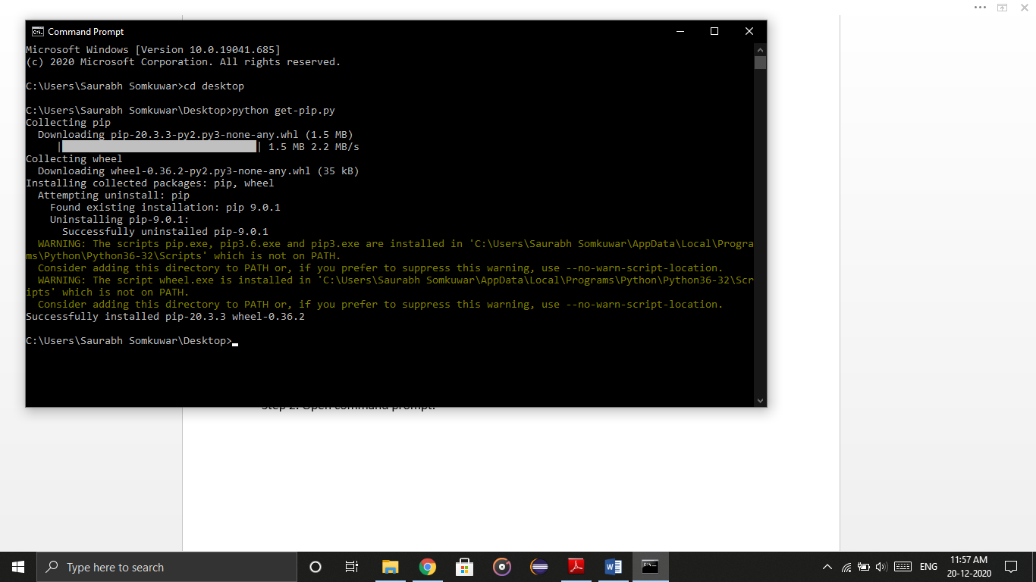

**Step 3:** Now open cmd again and install Jupyter Notebook by typing “pip install jupyter notebook”.

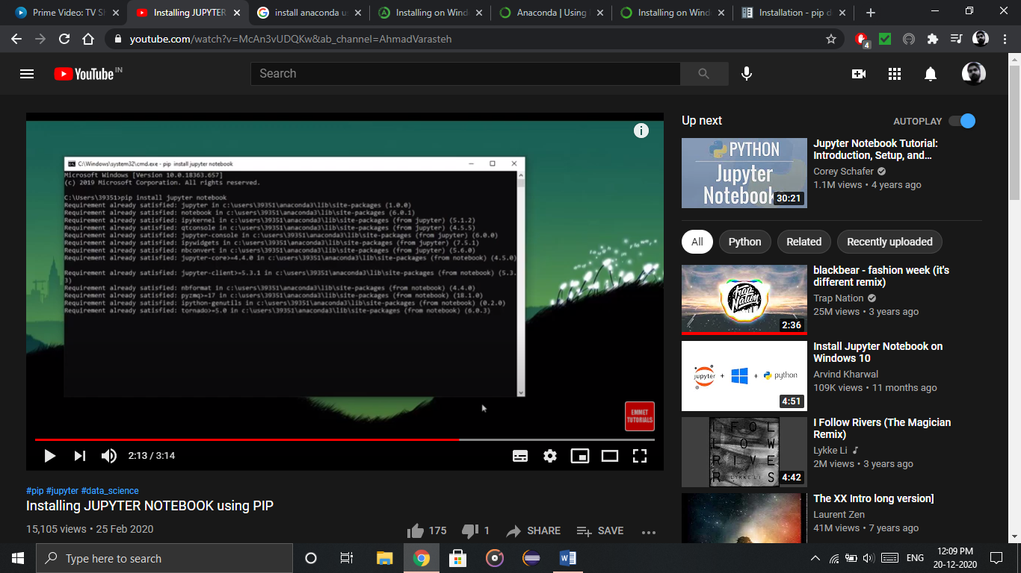

Done!! Your Jupyter Notebook is ready to use. Open cmd and just type jupyter notebook and press enter to launch it.

